Integrated Security System (ISS)
For
Sentosa Development Corporation (SDC)

Functional Requirements Document (FRD)
Case Management System
(Version 0.1)

 |  | Name | Designation / Company | Signature
Prepared By | : | Wong Shin Feng | Business Analyst (SJ)
Reviewed By | : | Gan Kian Teck | Application Lead (SJ)
 |  | Valerie Shao | Project Manager (NCS)
Approved By | :

Table of Contents
1. Document Control 7
1.1 Version History 7
1.2 Definitions, Abbreviations, Acronyms 7
2. Overview 9
2.1 Purpose and Scope 9
2.2 CMS Modules 9
2.3 Authentication and Access Control 10
2.3.1 Authentication Method 10
2.4 CMS Dashboard 10
2.4.1 Landing Page and Navigation 10
2.4.2 Summary Metrics 11
2.4.3 2D Island Map 11
2.5 Integration with Unified Command System 12
2.5.1 Live Metric Feed to UCS Dashboard 12
2.5.2 Embedded CMS Functions within UCS 12
2.5.3 Navigation from UCS to CMS 13
2.5.4 Navigation from UCS to CMS 13
2.5.5 Incident Creation from UCS 13
3. User Roles and Permissions 14
3.1 System Level Role Definitions 14
3.2 Contextual Roles 15
3.2.1 Owner 15
3.2.2 Responder 15
3.3 Duty Officer Role Elevation 15
3.4 Role and Status Action Matrix 16
3.4.1 Incident Management 16
3.4.2 Task Management 17
3.5 Record Data Retention 20
4. Case Data Model 21
4.1 Entity Structure and Relationships 21
4.2 Case Entity Relationship 21
4.3 Case ID and Naming Convention 22
4.4 Case Status Definitions 22
4.5 High-Level Case Process Flow 23
5. Incident Management Module 24
5.1 Incident Classification 24
5.1.1 Incident Types 24
5.1.2 Incident Categories 24
5.2 Crisis Incident Level Classification 25
5.3 Incident Field Design 25
5.3.1 General Information 25
5.3.2 Location 26
5.3.3 Incident Log 27
5.3.4 Emergency Services 28
5.3.5 Media Involvement 28
5.3.6 Property and Vehicles 29
5.3.7 Personal Injuries 30
5.3.8 Persons Involved 30
5.3.9 CCTV and Body Worn Camera 31
5.3.10 Attachments 32
5.3.11 Summary and Closure 32
5.4 Incident Lifecycle 32
5.4.1 Incident Status Definitions 33
5.4.2 High-Level Incident Process Flow 35
5.5 Incident Reporting Sources 35
5.6 Ranger Assignment and Response Tracking 36
5.6.1 Assignment 36
5.6.2 Response Milestone Tracking 37
5.6.3 Responder Activity Logging 37
5.7 Duplicate Incident Detection and Handling 37
5.8 Incident Record Save and Concurrent Editing 38
5.8.1 Save Mechanism 38
5.8.2 Concurrent Editing 38
5.9 Linked Fault Creation 38
5.10 False Alarm Handling 39
5.11 Incident Closure and Reopening 39
5.12 Broadcasting Triggers 39
5.12.1 Closure Broadcast 39
5.12.2 End-of-Day Interim Broadcast 39
6. Fault Reporting Module 40
6.1 Fault Entry Points 40
6.2 CMMS Ticket Creation 40
6.2.1 Requirements 40
6.2.2 Field Design 41
6.2.3 High-Level CMMS Ticket Process Flow 41
6.3 Fault Status and Information Retrieval 41
6.4 Non-IFM Fault Handling 41
6.5 Case Linkage and Closure 41
7. Task Management Module 42
7.1 Task Creation 42
7.1.1 Requirements 42
7.1.2 Task Field Design 42
7.2 Task Assignment and Notifications 43
7.3 Task Process 43
7.3.1 Requirements 43
7.3.2 Task Statuses 43
7.3.3 High-Level Task Process Flow 44
8. Occurrence Log 45
8.1 Occurrence Record Structure 45
8.2 Occurrence Creation 45
8.3 Retrieval and Filtering 45
8.4 UCS Integration 46
9. Broadcast and Notification Framework 47
9.1 Broadcast Types 47
9.2 Delivery Channels 47
9.3 Recipient Group Management 47
9.4 Broadcast Templates 48
9.5 Crisis Level Classification and Routing 48
9.6 Broadcast Matrix 49
9.7 SMS Recall Workflow 49
9.8 End-of-Day Interim Broadcast 49
9.9 SDC Communications Team Notification 49
9.10 Broadcast Record and Export 49
9.11 System Notifications 49
10. Reporting and Data Export 51
10.1 Incident Report Export 51
10.2 Case Summary Export 51
10.3 Data Export for Analytics 51
11. System Configuration and Administration 52
11.1 User and Role Management 52
11.2 System Reference Data Configuration 52
11.3 Broadcast Configuration 53
11.4 Audit Log 53
12. Non-Functional Requirements 54
12.1 Availability 54
12.2 Performance 54
12.3 Concurrent Users 54
12.4 Security 54
12.5 Session Management 54
12.6 Audit and Compliance 54
12.7 Data Retentional and Archival 54
13. Open Items 55
13.1 User Role and Permissions 55
13.2 UCS 55
13.3 Incident 55
13.4 Broadcast 55
14. Appendix 56

Document Control

Version History
Version | Date | Description
0.1 | 18 May 2026 | Initial Draft

Definitions, Abbreviations, Acronyms
Term | Definition
2FA | Two-Factor Authentication
AD | Active Directory
BWC | Body Worn Camera
CMS | Case Management System
CMMS | Computerised Maintenance Management System
DM | Duty Manager
DO | Duty Officer
FM | Facilities Management
FRD | Functional Requirements Document
HOTO | Handover and Takeover
IFM | Integrated Facilities Management
IIOC | Island Integrated Operations Centre
IOH | Integrated Operations Hub; used operationally to refer to the IIOC facility and its staff
LO | Liaison Officer
MOS | Method of Statement
NOP | No Objection Permit
NCS | NCS Pte Ltd
OR | Operational Resilience
PTZ | Pan-Tilt-Zoom
RA | Risk Assessment
RBAC | Role-Based Access Control
SCDF | Singapore Civil Defence Force
SCOG | Sentosa Crisis Operations Group
SCMG | Sentosa Crisis Management Group
SDC | Sentosa Development Corporation
SJ | Surbana Jurong
SPF | Singapore Police Force
SSO | Single Sign-On
UCS | Unified Command System
VA | Video Analytics
VMS | Video Management System
WOG | Whole-of-Government

Overview

Purpose and Scope
This document specifies the functional requirements for the Case Management System (CMS) component of the SDC Island Integrated Operations Centre platform, covering
- Incident Management
- Fault Reporting
- Task Management
- Broadcast and Notification
- CMS Dashboard
- System Configuration and Administration

CMS Modules
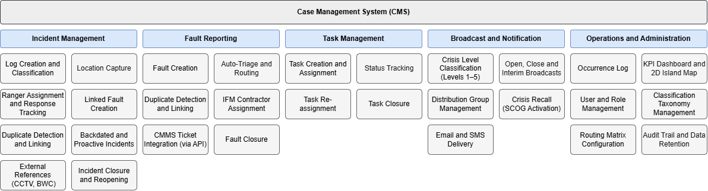
The CMS is a web browser-based platform. All modules are subject to role-based access control; the specific modules, tabs, and functions visible to a given user upon login are determined by their assigned role. The following modules are covered in this document.
Module | Description
Incident Management | Creation, assignment, tracking, and closure of incident records from all reporting sources across the island
Fault Reporting | Creation, automatic triage, routing, and closure of infrastructure fault records, with rule-based assignment to the appropriate IFM contractor and CMMS ticket creation via API where required
Task Management | Assignment and tracking of operational tasks directed to Rangers or SDC staff, linked to a parent Case
Broadcast and Notification | Structured framework for disseminating incident information to defined distribution groups, with crisis-level classification governing escalation and recall behaviour
CMS Dashboard | Consolidated operational view of active cases, incidents, faults, and tasks, with a filterable 2D map of island-wide activity
System Configuration | Administration of user accounts, role assignments, classification taxonomies, routing matrices, distribution groups, and audit settings

Authentication and Access Control

Authentication Method
Users authenticate to the CMS via Whole-of-Government Single Sign-On (WOG SSO). Two-Factor Authentication (2FA) is enforced for all user accounts. Access granted via WOG SSO may assign users a default role with minimal permissions, such as fault submission and status tracking, without requiring a separately provisioned CMS account

CMS Dashboard
The CMS Dashboard shall provide a consolidated operational view for Controllers, Duty Officers, and Duty Managers.
It is distinct from the UCS Dashboard in scope and purpose: the UCS Dashboard presents live-state summary counts and high-level situational awareness, while the CMS Dashboard provides access to both current and historical records with line-item detail views.

Landing Page and Navigation
Upon successful authentication, users are presented with the CMS landing page. Navigation items visible to a given user are filtered by their assigned role.
Navigation Item | Description
Dashboard | Consolidated operational view of active cases, incidents, faults, tasks, and 2D island map
Incident Management | Incident log list view, case creation, and incident detail view
Fault Reporting | Fault log list view, case creation, and fault detail view
Statistics | Aggregated operational reporting and data export
System Configuration | Administrator-only module for account management and system settings

Summary Metrics
The Dashboard shall display the following operational counters, each filterable by a date and time range selected by the user.
Metric | Description
Incidents Reported | Total count of incident records within the selected period
Unclosed Incidents | Count of incident records not in Closed status
Faults Reported | Total count of fault records within the selected period
Unclosed Faults | Count of fault records not in Closed status
Active Tasks | Count of task records currently in an active status

2D Island Map
The CMS Dashboard shall include an embedded 2D map of Sentosa Island leveraging on OneMap and its available API. The map will provide a consolidated spatial view of active operational activity across the island and is accessible to all users with Dashboard access.
Map Layer | Description
Incidents | Drop-pins for active and recent incident records, derived from the text-entered location data on each incident log. Coordinates are resolved from the entered address, road name, building, or postal code via the OneMap geocoding API
Faults | Drop-pins for active fault records, resolved by geocoding
Active Works | Boundary overlays for approved and active NOP works areas. Works boundaries drawn by NOP applicants during their application are automatically displayed on this map upon permit approval, providing Controllers with a live spatial overview of all ongoing permitted works on the island

- Geographical filtering shall be constrained to Sentosa Island, preventing drop-pins or overlays from being plotted outside the island boundary.
- For locations with defined physical boundaries, such as named buildings and venues, the system shall associate a text-entered location with the corresponding pinned coordinate.
- For road-based locations, which cannot be geofenced, coordinate resolution relies on the geocoding result returned by OneMap for the entered road name or common name.
- Island events at fixed venue sites, such as pavilions, event grounds, and beaches, shall be represented on the map as drop-pin icons.

Integration with Unified Command System
The CMS and the Unified Command System operate as complementary but functionally distinct platforms.
While the CMS is the system of record for all operational case data, the UCS is the primary command interface, surfacing a real-time operational overview to Controllers and the Duty Officer.

Live Metric Feed to UCS Dashboard
- The CMS shall supply real-time summary counts to the UCS Dashboard, including the number of active cases, open incidents, open faults, active tasks.
- Summary counts shall update in real time as records are created, updated or closed in the CMS.
- Detailed record lists and case-level views are not replicated on the UCS and reside exclusively within the CMS.

Embedded CMS Functions within UCS
- CMS functions that are frequently used or operationally time-critical shall be surfaced as embedded panels or inline actions within the UCS, without requiring the user to navigate away from the UCS interface.
- Actions performed through embedded UCS panels shall create, update, or retrieve records directly in the CMS. The UCS does not store or duplicate CMS data.
- The embedded functions shall operate under the same role-based access controls as the full CMS.
- Incident creation is a mandatory embedded function. A Controller shall be able to create a new Incident record from within the UCS without navigating to the CMS. See Section 2.5.3.
Note: The full list of CMS widgets/items to be made available as embedded widgets on the UCS dashboard is still under discussion with SDC.

Navigation from UCS to CMS
- When a Controller or Duty Officer selects a live metric or summary item on the UCS Dashboard, navigation directs the user to the corresponding CMS module page rather than a UCS sub-page.
- Line-item detail, record views, and case editing are handled entirely within the CMS and not replicated in the UCS.

Navigation from UCS to CMS
- Where a function is not available as an embedded UCS action, selecting a live metric, summary item, or record reference in the UCS shall direct the user to the corresponding CMS module page.
- Line-item detail, full record editing, case management, and reporting functions are handled within the CMS and are not replicated in the UCS.

Incident Creation from UCS
- A Controller shall be able to initiate a new Incident record directly from the UCS without navigating to the CMS.
- Incident creation from the UCS shall be available as an inline action, for example in response to a Video Analytics alert, a system-generated prompt, or a patrol report received in the UCS.
- The Incident record shall be created and stored in the CMS. The UCS surfaces the creation interface only; it does not own the record.
- Where a Video Analytics alert or system prompt is used as the trigger, the relevant alert reference shall be pre-populated into the Incident record where applicable.
- Upon successful creation, the Controller shall be able to continue monitoring the UCS or navigate directly to the full Incident record in the CMS.

User Roles and Permissions

System Level Role Definitions
The CMS defines the following system-level roles. A user's assigned role determines their permitted actions across all modules and records within the system.
Role | Description | System Access
System Administrator | Super Admin accounts holding maximum administrative rights, responsible for user provisioning, role configuration, taxonomy management, and system-level settings | Full, including System Configuration
Duty Manager | Senior operational authority on shift. Responsible for incident closure endorsement, escalation decisions, and endorsement of NOP applications | Full
Duty Officer | Senior officer on shift, supervising Controllers. Covers Duty Manager responsibilities during periods of absence under role elevation | Full
Controller | Primary IOH operator. Creates and manages incident and fault records, assigns Responders, routes tasks, and manages cases through to closure submission | Full access to case modules, but cannot independently close incidents
Responder (Ranger) | Field personnel assigned by a Controller to respond to an incident or task. Logs field activities and updates response status milestones within assigned records only | Limited to assigned incident and task record segments
Stakeholder | SDC internal staff with read access to incident records relevant to their department or operational zone | View-only
Broadcast Recipient | SDC staff or external stakeholders receiving incident broadcast notifications. No case creation or editing capability | Broadcast receipt only, full CMS account may not be required
Zone Manager | Manages a designated island zone or precinct. May be assigned tasks by the Controller | [TBC – System access for zone manager]
Operational Resilience Analyst | Read access to closed incident records for post-incident classification, tagging, and trend analysis. Does not create or edit operational records | - Read-only access to incident records  - Incident tagging and classification  - Bulk data export in CSV format
Note: System access for Zone Manager to be confirmed

Contextual Roles
Two roles are contextual, meaning they are determined by a user's relationship to a specific record rather than assigned at system level.

Owner
User who creates an incident or task record, typically a Controller. Owner permissions apply only to that specific record.

Responder
User assigned by the Owner or Controller to contribute field activity information to an incident or task. Responder permissions apply only to the specific record to which they are assigned.
Assigning a Responder is optional. A Controller may complete and submit a record without one.

Duty Officer Role Elevation
The Duty Officer may be elevated to cover Duty Manager responsibilities during the Duty Manager's absence. In the elevated state, the Duty Officer holds identical permissions to the Duty Manager.
Note: Approach for activating this elevation, assigned per shift via duty roster or applied as a long-term role configuration on a named user is still to be confirmed.

Role and Status Action Matrix

Incident Management
Incident records progress through the following statuses on the table header from left to right:
Role | Live | Live (Acknowledged) | Live (On-Site) / Live (Returned to Responder) | Live (Completed) | Pending Review | Returned | Closed
Owner* | - View  - Edit  - Assign Responder  - Submit for Review | - View  - Edit  - Assign Responder  - Submit for Review | - View  - Edit  - Assign Responder  - Submit for Review | - View  - Edit  - Assign Responder  - Submit for Review | View | - View  - Edit  - Assign Responder  - Submit for Review | View
Controller | - Create  - View  - Edit  - Assign Responder  - Submit for Review | - Create  - View  - Edit  - Assign Responder  - Submit for Review | - Create  - View  - Edit  - Assign Responder  - Submit for Review | - View  - Edit  - Return to Responder  - Submit for Review | View | - View  - Edit  - Assign Responder  - Submit for Review | View
Responder* | - View  - Acknowledge | - View  - Notify Arrival On-Site | - View  - Edit  - Notify Completion | View | View | View | Cannot View
Duty Officer | - View  - Edit  - Assign Responder  - Submit for Review | - View  - Edit  - Return to Owner  - Assign Responder | - View  - Edit  - Assign Responder  - Submit for Review | - View  - Edit  - Return to Responder  - Assign Responder  - Submit for Review | - View  - Edit  - Return to Owner  - Close | - View  - Edit  - Assign Responder  - Submit for Review | View
Duty Manager | - View  - Edit  - Assign Responder  - Submit for Review | - View  - Edit  - Return to Owner  - Assign Responder | - View  - Edit  - Assign Responder  - Submit for Review | - View  - Edit  - Return to Responder  - Assign Responder  - Submit for Review | - View  - Edit  - Return to Owner  - Close | - View  - Edit  - Assign Responder  - Submit for Review | View

Task Management
Task records progress through the following statuses: Created, Re-Assigned, Acknowledged, In Progress, Pending, Further Action, and Closed.
Role | Created | Re-Assigned | Acknowledged | In Progress | Pending Further Action | Closed
Owner* | - Create  - View  - Edit  - Assign Responder | - View  - Edit  - Assign Responder | View | View | View | View
Controller | - Create  - View  - Edit  - Assign Responder | - View  - Edit  - Assign Responder | View | View | View | View
Responder* | - View  - Acknowledge  - Re-assign | - View  - Acknowledge  - Re-assign | - View  - Notify Arrival On-Site | - View  - Edit  - Re-assign  - Set to Pending  - Close | - View  - Edit  - Re-assign  - Acknowledge | View
Duty Officer | - View  - Edit  - Assign Responder | - View  - Edit  - Assign Responder | View | View | View | View
Duty Manager | - View  - Edit  - Assign Responder | - View  - Edit  - Assign Responder | View | View | View | View
* Owner and Responder are contextual roles dependent on the specific task record.

Record Data Retention
When a user account is deactivated or removed, their associated records should remain accessible to users with appropriate role permissions, with the original creator's identity preserved on each record.

Case Data Model
The Case is the top-level record in the CMS. All operational activity is anchored to a Case.

Entity Structure and Relationships
- A Case may be created independently of any child record.
- A Case may contain zero or one Incident record.
- A Case may contain zero or more Task records.
- A Case may reference zero or more CMMS Ticket IDs. These identifiers are returned by the IFM CMMS upon ticket creation and stored as reference attributes of the Case. The ticket lifecycle is owned entirely by the IFM CMMS.
- An Incident, Task, or CMMS Ticket reference cannot exist in the CMS without an associated Case.
- Where a Case does not exist at the time of Incident or Task creation, the system shall auto-create a Case before creating the child record.
- Occurrence records are standalone entries, not associated with the Case record structure.

Case Entity Relationship
The following diagram illustrates the relationship between the Case and its linked record types.
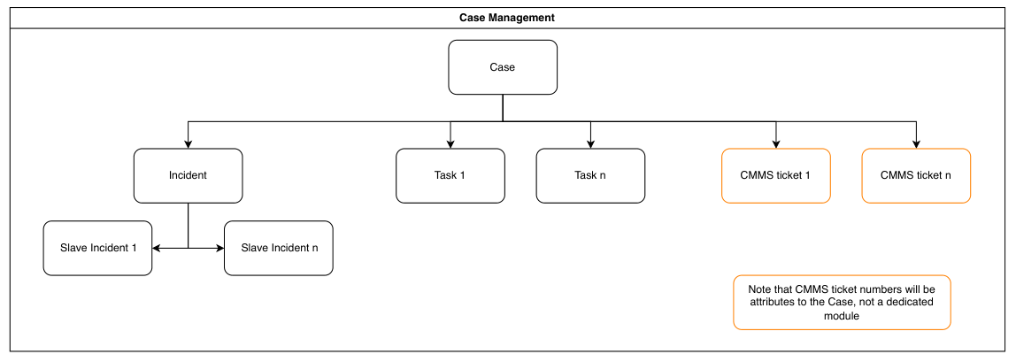
Figure 5-1 - Case Entity Relationship Model
Entity | Cardinality | Description
Case | Parent | The operational record container. One Case is created per operational event
Incident | Zero or one per Case | The formal incident record managed by the Controller. A Case may contain at most one Incident
Linked (Slave) Incident | Zero or many per Incident | Duplicate incident reports linked to a Master Incident.
Task | Zero or many per Case | Operational ground response tasks assigned to Rangers or SDC staff. Multiple Tasks may exist under one Case simultaneously.
CMMS Ticket ID | Zero or many per Case | Reference identifiers for tickets raised in the IFM contractor's CMMS via API.  Stored as attributes on the Case.  CMMS ticket lifecycle is managed externally.

Case ID and Naming Convention
- System shall generate a unique identifier upon creation.
- The Case ID follows the format YYYY/MM/NNNN, where YYYY is the four-digit year, MM is the two-digit month, and NNNN is a zero-padded sequential number resetting at the start of each month.
- The Case ID is referenced by all child records (Incident, Tasks) for traceability.

Case Status Definitions
Status | Description
Pending Triage | Initial status on Case creation. The Controller has not yet determined whether action is required
Active | Action has been determined as required. One or more sub-processes (Incident, Task, CMMS Ticket) are in progress
Closed | All linked Incident, Task, and CMMS Ticket records are resolved. The Case is read-only

The Controller may close a Case after a CMMS Ticket has been raised, without waiting for the IFM contractor to resolve the ticket.

High-Level Case Process Flow
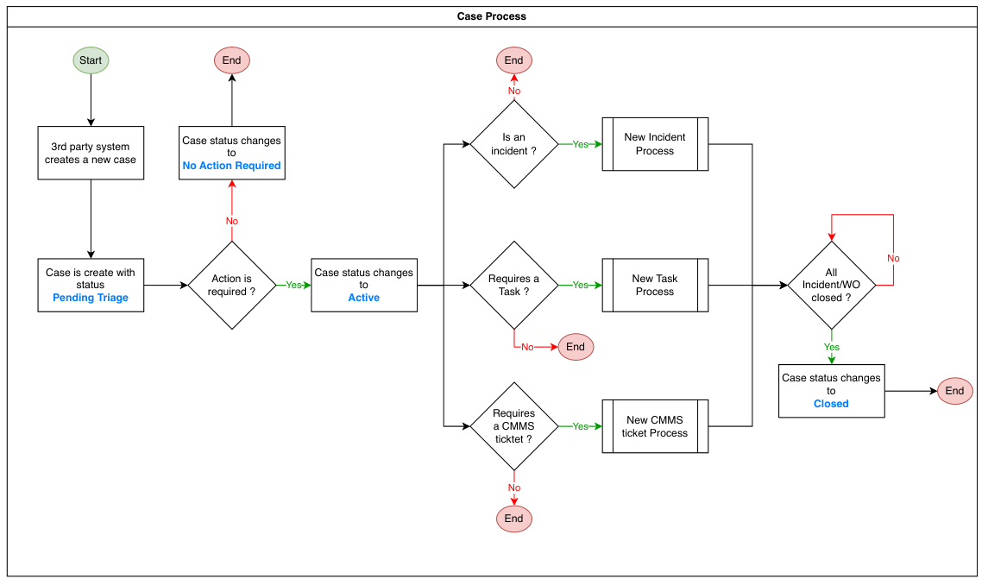
Figure 5-2 - Case Process Workflow

Incident Management Module
The Case is the primary operational record container in the CMS. Every operational activity on the island, whether an incident, a ground response task, or an infrastructure fault requiring contractor action, is anchored to a Case record.

Incident Classification

Incident Types
- Each incident record shall be assigned a Type and a Sub-type from SDC's defined classification taxonomy.
- Both Type and Sub-type fields are mandatory.
- Sub-type values are unique within each Type. An Others option shall be available as a Sub-type of last resort where no defined Sub-type accurately describes the incident.
Note: Finalised Incident Type and Sub-type taxonomy to be confirmed

Incident Categories
Beyond Type and Sub-type, the following operational categories apply to incident records and govern how they are handled within the system. These categories are for-info and not noted in the system.
Category | Description
Standard Incident | An active incident requiring Controller management and, where applicable, a Ranger field response
Proactive Incident | Created by the Controller in response to a notification or advisory where no immediate ground response is required. Common examples include missing person lookouts and lost item notices
Backdated Incident | Created to record an incident that has already occurred and concluded, typically following notification from a state agency after the fact. The record is created, populated with the known details, and closed immediately
Ongoing Incident | An incident that remains open over an extended period while the situation develops and is actively monitored. Common examples include prolonged state emergencies or extended search operations
Operational Record | An administrative record created for tracking purposes, covering planned exercises, drills, or coordinated information dissemination. These records do not require a ground response or broadcast

Crisis Incident Level Classification
- Each Incident shall be assigned a Crisis Level at the point of creation or escalation by a Controller
- The Crisis Level determines the broadcast type, distribution group, and escalation behaviour triggered upon or during the incident.
- The crisis level is assigned by the Controller at the point of incident creation and may be escalated by the Duty Manager or Duty Officer as the incident develops.
Note: Full classification and routing behaviour is defined in further sections on Broadcasts.

Incident Field Design
The incident record is structured into the following sections. Fields marked as mandatory must be completed before the record can be submitted for review.

General Information
Field | Type | Mandatory | Notes
Case ID | Auto generated | - | System-generated unique identifier. Read-only.
Case Title | Text | Yes | Auto generated when incident is triggered by a third-party system, e.g. "VA: Abandoned Object @ Cove". Manually entered by Controller for all other incidents
Date and Time of Incident | Date/Time | Yes | Defaults to current date and time. Backdating is permitted with no restriction
Incident Type | Dropdown | Yes | Selected from SDC's defined taxonomy. Refer to Appendix C
Incident Sub-type | Dropdown | Yes | Values are unique within the selected Incident Type. Refer to Appendix C
Priority | Dropdown | TBC
Reporter's Name | Text | No | Refers to the source of the incident report, not the Controller completing the form
Requested By | Text / Dropdown | No | The party who initiated the report or requested action
Created By | Auto | - | Populated from the authenticated user account. Read-only
Status | System-managed | - | Not manually editable. Refer to Section 6.2 for status definitions
Assigned To | User | No | Ranger or Responder assigned by the Controller

Location
Field | Type | Mandatory | Notes
Road | Text | No | Road name or nearest road reference
Building | Text | No | Building name where applicable
Level and Space | Text | No | Floor level and specific space within the building
Beside / Near To / At | Text | No | Directional qualifier, e.g. "Lane 2", "near the entrance"
Common Name | Text | No | Free text accepting building names, lamp post numbers, or bus stop numbers
Postal Code | Text | No | Defaults to 000000 for locations without a postal code
Location Tags | Tags | No | Predefined zone and facility tags for filtering and reporting
Minimap | Map display | - | Displayed after location entry for address confirmation. Reference only, not interactive

Incident Log
The Incident Log section captures a chronological, row-by-row account of the incident as it unfolds. Each row is timestamped and auto sorted by date and time.
Field | Type | Mandatory | Notes
Event Number | Auto generated | - | Sequentially assigned per row
Date | Date | Yes (per row) | Date of the event entry
Time | Time | Yes (per row) | Time of the event entry
Event Description | Free text | Yes (per row) | Controller's account of the event at that point in time

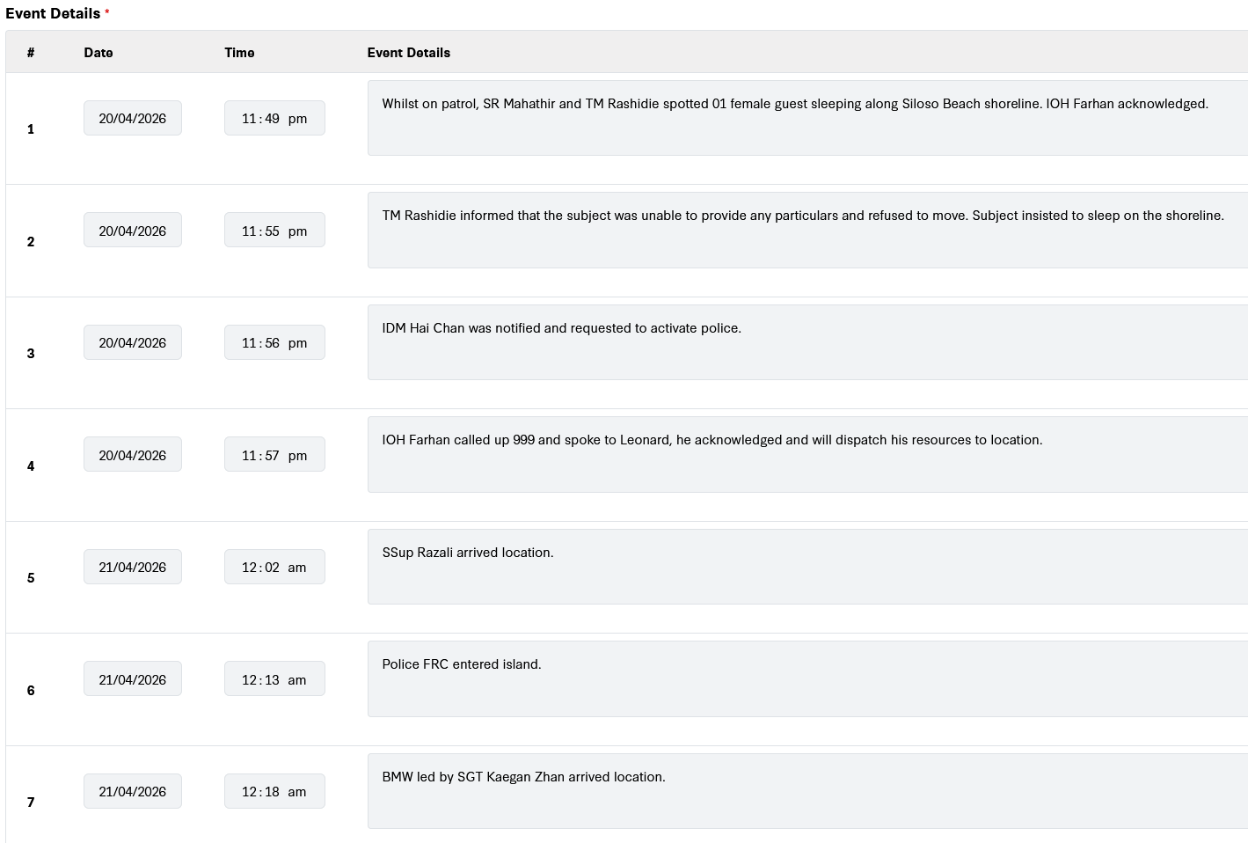
Sample screenshot of Event Details logging

Emergency Services

Police
Field | Type | Mandatory | Notes
Police at Scene | Checkbox | No | Indicates police presence at the incident
Officer Name and Rank | Text | No | Name and rank of the attending officer
Police Incident Number | Text | No | Reference number from the police
Classification | Text | No | Police classification of the incident
Responding Unit | Text | No | Unit or station responding

Ambulance and SCDF
Field | Type | Mandatory | Notes
Type | Dropdown | No | Ambulance or SCDF
Officer Name | Text | No
Call Sign | Text | No
Responding Unit | Text | No
Arrival Time | Time | No
Hospital Conveyed To | Text | No | Name of hospital if patient was conveyed

Media Involvement
Field | Type | Mandatory | Notes
Media at Scene | Checkbox | No | Indicates media presence at the incident
Media Name | Text | No | Name of the media organisation or outlet present
SDC Comms Notification | Prompt | — | A prompt or reminder mechanism shall be surfaced when media presence is indicated, to ensure the Controller notifies the SDC Communications team.

Property and Vehicles

Property Damage
Field | Type | Mandatory | Notes
SDC Property Damaged | Checkbox | No | Indicates whether SDC-owned property was damaged in the incident
Description | Text | No | Description of damage where applicable

Vehicles Involved
Field | Type | Mandatory | Notes
SDC Vehicle Involved | Checkbox | No | Indicates whether an SDC-owned vehicle was involved
Vehicle Model | Text | No
Vehicle Number | Text | No
Driver Name | Text | No
Driver Contact Number | Text | No
Driving Licence Number | Text | No
Driver Address | Text | No
Remarks | Text | No

Personal Injuries
Field | Type | Mandatory | Notes
Name | Text | No
Address | Text | No
Age | Number | No
Gender | Dropdown | No
Contact Number | Text | No
Clinic or Hospital Attended | Text | No
MSIG Form Issued, | Checkbox + Text | No | Indicates whether an MSIG form was issued. If yes, Serial Number field is surfaced
Under-16 Indicator | Checkbox | No | If the injured person is aged 16 or below, a parental or guardian details sub-form is surfaced
Parent or Guardian Name | Text | No | Surfaced conditionally when under-16 indicator is selected
Parent or Guardian Contact | Text | No | Surfaced conditionally when under-16 indicator is selected

Persons Involved
Field | Type | Mandatory | Notes
Guest or non-Guest | Dropdown | No | Indicates whether the person is a guest of the island or otherwise
Type | Dropdown | No | Guest, Staff, Island Partner or Contractor, Resident, Others
Name | Text | No
Address | Text | No
Age | Number | No
Gender | Dropdown | No
Contact Number | Text | No
Role or Involvement | Text | No | Free text describing the person's role, e.g. victim, witness, bystander
Injury Details | Text | No | Surfaced if the person sustained an injury

CCTV and Body Worn Camera
This section records references to CCTV footage and Body Worn Camera footage relevant to the incident. Multiple entries are supported for incidents spanning several locations or involving multiple officers.
Footage retrieval is performed via the VMS and is not accessible directly from within the CMS.
Field | Type | Mandatory | Notes
Camera Number | Text | No | Multiple entries supported
VMS Timestamp | Time | No
VMS Footage Bookmark | Text | No | Reference bookmark within the VMS footage
BWC Number | Text | No | Body Worn Camera identifier
BWC Timestamp | Time | No

Attachments
Field | Type | Mandatory | Notes
Attachments | File upload | No | Accepted formats: photo, video, and document files. Police reports shall not be attached in this section

Summary and Closure
Field | Type | Mandatory | Notes
Summary | Rich text | No | Free-text summary field, relocated below the Personal Injuries section. Renamed from Remarks in the previous system
Completion Remarks | Text | No | Entered by the Responder upon completion of ground activities
Closed By | Auto | - | Populated from the authenticated user account upon closure. Read-only
Closed At | Auto timestamp | - | System timestamp recorded at the point of closure. Read-only

Incident Lifecycle
- An Incident record shall be created either manually by a Controller or automatically triggered from a third-party source or the UCS.
- Where a Case does not already exist, Case creation is triggered automatically before the Incident record is initialised.
- The Controller may assign one or more Responders to the Incident. Assignment is optional; an Incident may be managed without a Responder assigned.
- The Incident progresses through defined statuses reflecting its operational state.
- Upon closure, the system shall automatically record the identity of the closing user and the closure timestamp.
- Closed Incident records are read-only. A System Administrator must revert the status to an active state before any edits can be made.

Incident Status Definitions
Status | Description | Permitted Actions
Live | Incident created and active. No Responder acknowledged. | Controller  - Edit  - Assign Responder  - Mark false alarm  - Submit for closure
Live (Acknowledged) | Assigned Responder has acknowledged. | Controller:  - Edit  - Reassign  Responder:  - Update to On-Site  - Log activity
Live (On-Site) | Responder confirmed on location. | Controller:  - Edit  Responder:  - Update to Completed  - Log activity
Live (Returned to Responder) | Duty Manager has returned the record for further action. | Controller:  - Edit  - Resubmit  Responder:  - Update  - Log activity
Live (Completed) | Responder has marked as completed. Pending Duty Manager review. | Duty Manager:  - Approve closure or return  Controller:  - View only
Pending Review | Submitted for Duty Manager approval before closure. | Duty Manager:  - Approve closure or return.  Controller:  - View only
Returned | Duty Manager returned the record. | Controller:  - Edit  - Resubmit  Responder:  - Update
Closed | Approved for closure. Record is read-only. | System Administrator:  - Revert status  All roles:  - Read only
Note: Full role-by-role action permissions across all statuses are defined in the Role and Permission Matrix, Section 3.4.2

High-Level Incident Process Flow
The following diagram illustrates the end-to-end incident lifecycle from creation through to closure.
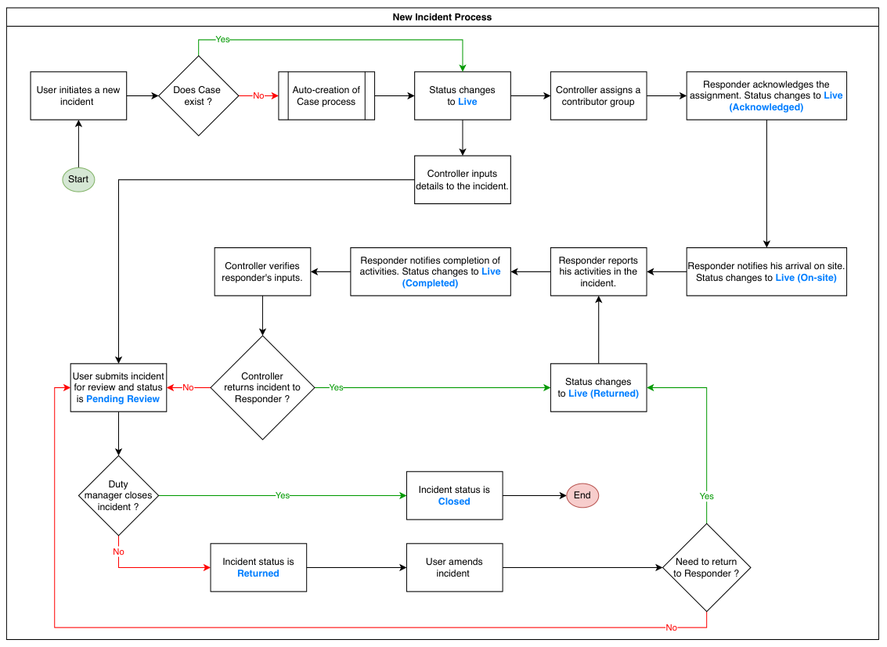
Figure 6-1 - Incident Creation and Assignment Workflow

Incident Reporting Sources
- All Incident records, regardless of source, area created manually by a Controller within the CMS or from within the UCS.
- The originating source shall be recorded as a field on the Incident record for audit and reporting purposes.
- The VA system does not create incident records autonomously, Controllers review and confirm each alert before a record is created.
Source | Channel | Logging Method
Guest or Member of Public | 1800 duty phone. Controller receives the call directly | Manual. Controller creates the incident record during or after the call
Guest or Member of Public | Email to SDC's contact address | Manual. Controller creates the incident record upon reviewing the email
Staff or First Responder | Duty phone, direct call, or WhatsApp | Manual. Controller creates the incident record from details communicated by the staff member
Video Analytics System | VA alert surfaced on the UCS. Controller reviews the alert and determines whether it is genuine | Manual. Controller creates the incident record from within the UCS if the alert is confirmed genuine.  Where a Controller acknowledges the alert but is unable to complete the record, the incomplete item remains visible in the UCS open case list for pickup by another Controller
Fire Alarm System | Fire alarm alert triggered at the IIOC | Manual. Controller creates the incident record upon receiving the alert
Carpark Intercom | Two-way intercom between a driver at the carpark gantry and the IIOC | Manual. Controller creates an incident record only where the interaction requires follow-up action, such as a barrier fault. Routine interactions that require no follow-up are not logged
State Agency (SCDF, SPF, MPA) | State agency contacts the IIOC duty phone to notify of an incident | Manual. Controller creates the incident record from the details communicated. Where the state agency notifies SDC of an incident that has already concluded, the Controller creates a backdated incident record and closes it immediately. No system integration exists between the CMS and any state agency

Ranger Assignment and Response Tracking

Assignment
- A Controller may assign one or more Rangers or CMS-registered staff to an Incident as Responders.
- Assignment may occur at creation or at any point while the Incident is in a Live status.
- The system shall notify the assigned Responder upon assignment via the configured notification channel.
- Multiple Responders may be assigned to a single Incident.
- A Responder may be reassigned by a Controller while the Incident is active.

Response Milestone Tracking
The system shall record the following response milestones against each assigned incident:
Milestone | Status Transition | Recorded By
Dispatch | Incident assigned by Controller; status remains Live | Controller
Acknowledgement | Ranger confirms receipt of assignment | Responder. Status changes to Live (Acknowledged)
Arrival on Site | Ranger confirms arrival at the incident location | Responder. Status changes to Live (On-Site)
Activity Updates | Ranger logs actions taken at scene | Responder. Free text entries within the Responder activity section
Completion | Ranger notifies completion of ground activities | Responder. Status changes to Live (Completed)

Responder Activity Logging
The Responder Activity section is a dedicated segment within the incident record, separate from the Event Details section. It is accessible only to the assigned Responder and is used to log the actions taken during the ground response.
- Responders shall be able to log activity updates against an Incident
- Selection of activity list should support typing for free-text, but also support auto-complete from a predefined activity list to guide Responders to quick-fill
- Activity log entries are timestamped and attributed to the logging user.
- Activity logs are read-only once submitted and are not editable by the Responder.
- Activity log entries are visible to Controllers and Duty Managers in the Incident record view.

Duplicate Incident Detection and Handling
Multiple reports of the same incident may be received concurrently from different sources, e.g. several guests calling the 1800 hotline about the same event within a short period.
- The system shall flag the Controller when a potential duplicate incident is detected during manual creation, based on matching criteria including date, time, incident type, and sub-type.
- The Controller retains the option to proceed with creating a new record, override the duplicate flag, or link the new record to an existing incident
- Where a record is confirmed as a duplicate, it shall be marked as a linked duplicate and not treated as an independent active Incident
- Linked duplicates shall not generate independent response workflows or separate broadcast triggers
- Closing the Master Incident shall automatically close all linked duplicate records.

Incident Record Save and Concurrent Editing

Save Mechanism
- The system shall auto-save all form input at regular intervals while an incident record is being edited, to minimise data loss in the event of session timeout or interruption.
- A manual save action shall also be available to the user at any point during editing.
- A record in an unsaved state shall display a visible indicator to the user.
- Unsaved changes shall not be discarded without user confirmation.
- The auto-save interval shall be configurable by the System Administrator.

Concurrent Editing
- Where two Controllers access and edit the same incident record simultaneously, the system shall manage the conflict to prevent one Controller's saved input from silently overwriting the others without notification.
Scenario | Required Behaviour
Second user opens a record already being edited | The system shall notify the second user that the record is currently being edited by another user
Both users save changes to the same record | The system shall not silently discard either user's input. A conflict resolution mechanism shall be applied to surface the discrepancy and prompt resolution

Linked Fault Creation
Where an incident reveals an underlying infrastructure defect, a Fault Report may be created directly from the incident record.
- A Controller may raise a fault record from within an active Incident where physical defect is identified as part of or resulting from the incident.
- Fault creation from an Incident record shall initiate the CMMS ticket creation workflow
- The fault record shall be linked to the originating incident and shall be visible from both the incident and fault detail views.
- The incident and fault are managed independently once created. Either may be closed before the other.
- Incident may be closed after the immediate situation is resolved while the fault record remains open as the infrastructure repair and investigation continue.

False Alarm Handling
- Where an incoming report or VA alert is reviewed by the Controller and determined to require no action, the Controller may log the record and mark it as a false alarm.
- A false alarm record, including the identity of the closing user, shall be retained in the system as a closed record for audit and reporting purposes.

Incident Closure and Reopening
- Incident closure requires Duty Manager or designated in-charge approval, except for false alarm closures
- A Controller shall submit an Incident for closure by transitioning it to Pending Review status
- The Duty Manager shall review the record and either approve closure or return it with comments.
- Upon approval, the Incident status changes to Closed and the Case closure process is triggered if all linked records are resolve.
- To reopen a closed incident, a System Administrator must revert the status from Closed to the appropriate active status.
- Upon closure, the system shall automatically trigger a closure broadcast.

Broadcasting Triggers
Broadcast specifications including delivery channels, templates, recipient group management, crisis level classification, and the routing matrix are defined in Section 10: Broadcast and Notification Framework.

Closure Broadcast
- The system shall automatically trigger a closure broadcast when the Duty Manager or designated In-charge approves incident closure.
- The system shall dispatch the broadcast to the configured recipient group without requiring a separate manual send action from the Controller.
- One closure broadcast shall be issued per incident.

End-of-Day Interim Broadcast
- For incidents that remain active at the end of the operational day, the system shall flag open incidents for inclusion in the end-of-day batch review queue.
- The Duty Manager reviews and approves dispatch for each flagged incident

Fault Reporting Module
The Fault Reporting module is the single point of entry within the CMS for logging fault records and initiating ticket creation in the IFM CMMS.
- Triage, routing and severity classification of faults are handled by the IFM on the CMMS. The CMS does not replicate or manage any part of the fault or work order lifecycle
- The CMS role includes:
- Data Capture at point of fault submission
- Ticket creation in the CMMS
- Storage of the returned CMMS Fault ID in the Case record
- Subsequent retrieval of fault information from the CMMS using that stored identifier

Fault Entry Points
Fault records may be created within the CMS through the following entry points:
Entry Point | Description
From an active Incident record | A Controller raises a fault from within an active Incident where a physical defect is identified as part of or resulting from the Incident.
Standalone Case | A Controller creates a fault as a standalone Case where a fault is reported directly, independent of any Incident.
SDC Staff Application | SDC staff submit a fault report through the Staff Application, which routes the submission into the CMS.
All fault submissions shall be routed through the CMS as the single point of entry for submission.

CMMS Ticket Creation

Requirements
- Upon fault submission, the system shall check whether an existing Case is associated with the request.
- Where no Case exists, the system shall auto-create a Case before proceeding with ticket creation
- The CMMS returns a Ticket ID upon successful creation, which the system stores as an attribute on the Case record.
- The CMMS subsequently manages and updates the ticket status independently of the CMS.

Field Design
The fields captured by the CMS at the point of fault creation, and transmitted to the CMMS API, shall be defined in alignment with the CMMS API specifications.

High-Level CMMS Ticket Process Flow
The process flow for CMMS ticket creation is illustrated in the diagram below.
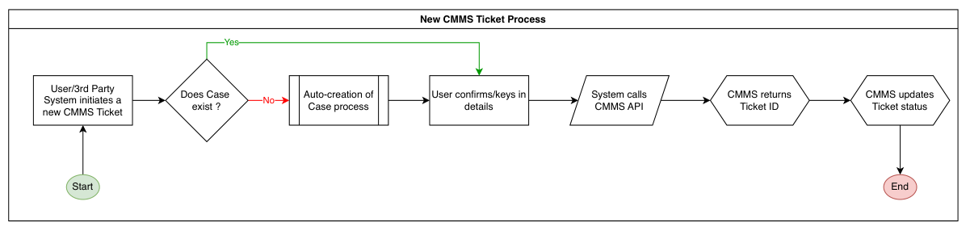
Figure 7-1 - CMMS Ticket Process

Fault Status and Information Retrieval
- Where fault status or details are required within the CMS, the system shall post a request to the CMMS API referencing the stored Fault ID to retrieve the relevant information.
- Retrieved fault data shall be surfaced on the associated Case record for operator reference.

Non-IFM Fault Handling
- Faults that fall outside current IFM CMMS scope, the interim arrangement is for these to continue to be recorded in the existing physical logbooks and not logged within the CMS.
Note: This arrangement will be revised once the IFM CMMS is expanded to cover non-IFM fault categories, at which point the CMS will route all fault submissions through the CMMS API.

Case Linkage and Closure
- The CMMS Fault ID shall be stored as a reference attribute on the CMS Case
- The CMMS Fault ID shall not drive the Case lifecycle. The Case status is independent of the CMMS ticket status
- A Case may be closed after the CMMS ticket has been raised, without waiting for the CMMS ticket to be resolved.
- Multiple CMMS Fault IDs may be stored in a single Case where more than one fault is raised.

Task Management Module
Tasks are non-FM operational activities assigned to SDC staff for ground response or follow-up actions that do not constitute a formal FM work order.
- Tasks are created by Controllers and are always linked to a Case.
- A Task may exist within a Case independently of an Incident, or alongside an Incident where parallel ground activity is required.
- Tasks are distinct from the Responder Activity log within an Incident record, which captures actions taken by an assigned Ranger during the incident response.
- Tasks are distinct from CMMS tickets, which are FM work orders managed externally.

Task Creation
A Controller may create a Task at any point during the lifecycle of a Case. The system shall allow multiple Tasks to be created under the same Case.

Requirements
- Tasks are created by Controllers and are always linked to Case
- A Task is linked to a Case and is not required to be associated with an Incident.
- Tasks may be created for any operational ground activity, including standalone requests such as item collection, escort, or access arrangements, as well as activities arising from or running in parallel with an active Incident.

Task Field Design
The following fields shall be captured at the point of Task creation:
Field | Input Type | Mandatory | Notes
Task ID | System | Yes | System-generated upon Task creation. Not manually editable.
Linked Case ID | System | Yes | Auto populated from the Case the Task is created within.
Task Title | Text | Yes | Free text
Task Description | Text | No | Free text. Additional detail on the required action.
Assignee | Lookup | Yes | Selected from the CMS user directory. Any CMS-registered staff member may be assigned. See Section 3.
Priority | Dropdown | No
Due Date and Time | Date/Time | No | Optional target completion date and time
Attachments | File upload | No | Supporting documents or images relevant to the Task
Created By | System | Yes | Auto-populated from the creating user's account.
Created Date and Time | System | Yes | Auto-populated at point of creation.

Task Assignment and Notifications
- The system shall dispatch a notification to the assignee upon Task creation.
- Where a Task is subsequently reassigned, the new assignee shall receive a notification, and the Task status shall update to Re-Assigned.
- Tasks may be assigned to any SDC staff with a CMS account, including but not limited to Rangers and Zone Managers.
- The assignee shall update the Task status to reflect completion and may close a Task directly upon completion.
- No Controller verification step is required for Task closure.

Task Process

Requirements
- Status transitions per role are defined in the Roles and Permission Matrix, Section 3.4.2
- The Controller retains visibility of all Task statuses within the linked Case.
- Where a Case is closed while one or more linked Tasks remain open, the system shall prompt the Controller to resolve of close outstanding Tasks before Case closure proceeds.

Task Statuses
Each Task shall progress through the following statuses:
Status | Description
Created | Task has been created and assigned by the Controller
Re-Assigned | Task has been reassigned to a different staff member
Acknowledged | Assignee has acknowledged receipt of the Task
In Progress | Assignee has commenced work on the Task
Pending | Task is temporarily on hold pending further input or external dependency
Further Action | Task requires additional follow-up action before closure
Closed | Task has been completed and closed

High-Level Task Process Flow
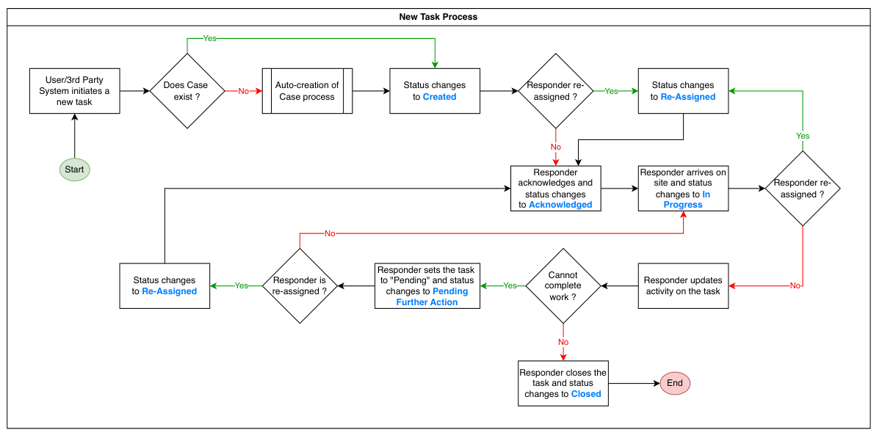
Figure 8-1 - Task Process

Occurrence Log
The Occurrence Log is a standalone module for recording events and interactions that fall under IOH responsibility but do not meet the threshold for a formal incident, fault, or task. The module digitises existing hardcopy occurrence logbooks currently maintained by the IOH team, providing a searchable and filterable electronic record in place of the physical diary.
Occurrence records do not trigger a ground response, work order, or broadcast, and are not linked to the Case structure.
Common use cases include verbal interactions with members of the public, VIP and dignitary visit notifications, exercises, drills, and information dissemination activities.

Occurrence Record Structure
Each occurrence entry shall capture the following fields:
Field | Notes
Occurrence ID | System-generated
User | Account holder creating the entry. System-populated from authenticated session
Date / Time | Defaulted to current date and time. Backdating permitted
Topic | Structured or free text
Content | Free text narrative

Occurrence Creation
- Any authorised user with a CMS account may create an occurrence entry.
- Creation requires no approval or assignment workflow.
- Once submitted, the entry is recorded and immutable.

Retrieval and Filtering
- The system shall support retrieval of occurrence entries with filtering by date and by user account.
- Additional filtering criteria may be introduced subject to the confirmed field list from SDC.

UCS Integration
- The Occurrence Log shall be accessible as an e-Diary module within the UCS, allowing Controllers and Duty Officers to create and retrieve occurrence entries without navigating to the CMS.
- The UCS surface requirements for the Occurrence Log are defined within the UCS Functional Requirements Document.

Broadcast and Notification Framework
The Broadcast and Notification Framework govern the composition, delivery, and record-keeping of all outbound communications generated by the CMS. Broadcasts are structured communications issued to defined recipient groups in response to incident lifecycle events.
Notifications are system-generated alerts directed to individual users in response to record assignments, status changes, or workflow actions.

Broadcast Types
Broadcast Type | Trigger | Initiator
Closure Broadcast | Duty Manager or In-charge approves incident closure | System, upon closure approval
End-of-Day Interim Broadcast | End of operational day | Duty Manager, via batch review queue
Crisis Recall | Incident classified at Level 4+ or above | Semi-automated, human confirmation required before dispatch
Each broadcast shall be assigned a system-generated Broadcast ID following the convention: [Case ID]-BC[3-digit running sequence starting from 001].
Example: The second broadcast issued against Case 2002/01/0004 shall be 2002/01/0004-BC002.

Delivery Channels
Channel | Used For | Notes
Email | Closure broadcasts; end-of-day interim broadcasts | Directed to configured distribution groups
SMS | Crisis recall at Level 4+ and above | Includes recipient acknowledgement feature; routed via SMS gateway integrated with on-premises UCS

Recipient Group Management
- Distribution groups shall be managed as named collections of user email addresses, configurable by the System Administrator.
- The system shall support creation, editing, and deactivation of distribution groups.
- Known standing groups include the Sentosa Crisis Operations Group and the SC Management Group.
- On broadcast initiation, the system shall pre-populate the recipient field with the default distribution group mapped to the incident type and crisis level.
- The Duty Manager or Controller may add or remove individual recipients prior to dispatch without modifying the group configuration permanently.

Broadcast Templates
- The system shall support configurable broadcast templates mapped to incident type and crisis level.
- Templates shall define the default set of incident fields included in the broadcast.
- Default templates shall be configured to exclude sensitive content, defined as details that are operationally sensitive, under active investigation, or unsafe for wider distribution.
- Inclusion of fields beyond the default requires explicit confirmation by the Duty Manager at the point of dispatch.
- Templates shall be configurable by the System Administrator
Note: Broadcast template content per incident type and crisis level to be confirmed.

Crisis Level Classification and Routing
Each incident shall be assigned a crisis level from 1 to 5 that determines the broadcast type, delivery channel, and recipient group as follows:
Crisis Level | Description | Broadcast Behaviour
Level 1–3 | High-severity incidents | Fixed broadcast via email, select recall via SMS with acknowledgement to defined distribution groups
Level 4+ | Incidents requiring SCOG activation | Fixed broadcast via email, select recall via SMS with acknowledgement to defined distribution groups
Level 4 | Routing incidents | Targeted email broadcast to relevant distribution groups
Level 5 | Occurrences and false alarms | Targeted email broadcast to relevant distribution groups
Crisis level may be influenced by dynamic factors including media or press presence, reputational impact, and number of persons involved. Escalation to Level 4+ or above shall require human confirmation from an authorised user prior to SCOG recall dispatch.

Broadcast Matrix
[TBC – Full broadcast matrix]

SMS Recall Workflow
- For incidents at Level 4+ and above, the system shall generate and queue a crisis recall SMS based on the incident classification and configured recipient group.
- An authorised user shall review and confirm the queued message before dispatch.
- The system shall surface SMS acknowledgement status to the Duty Manager upon receipt by recipients.

End-of-Day Interim Broadcast
- At the end of each operational day, the system shall surface a queue of open incidents flagged for interim broadcast to the Duty Manager.
- For each incident in the queue, the Duty Manager shall select the applicable template, confirm the content to be included, and approve dispatch.
Note: Broadcast timing rules and criteria governing which active incidents are surfaced in the interim broadcast queue are to be determined.

SDC Communications Team Notification
- When media is confirmed or suspected to be present at an incident scene, the system shall prompt the Controller to notify the SDC Communications team by broadcast.
- This broadcast would include details of the incident and the media organisation that is present.
- The incident record shall include a field to log confirmation that this notification has been made.

Broadcast Record and Export
- All dispatched broadcasts shall be logged against the originating Case record and identified by Broadcast ID.
- The system shall retain a full record of each broadcast including the recipient list, template used, content dispatched, date and time of dispatch, and the authorising user.
- Broadcast content shall be included as a section within the incident report export. The broadcast export format may differ from the full incident report format and shall present a concise summary suitable for record-keeping purposes.

System Notifications
The system shall generate automated notifications to individual users for the following events:
Event | Recipient
Task assigned or reassigned | Assignee
Incident assigned for Responder Activity | Responder
Incident returned for revision | Controller or Responder
NOP status change | Applicant and relevant approvers
CMMS Fault ID received | Controller of linked Case

Reporting and Data Export
The Reporting and Data Export module provides structured exports of CMS records for operational record-keeping, management review, and downstream analytics.
Export outputs are distinct from broadcast content. Fields included in an export may differ from those included in a broadcast for the same incident.

Incident Report Export
- The system shall support export of a formal incident report for each closed incident.
- The report shall present a structured summary of the incident record fields and shall be exportable in PDF format.
- The fields included in the incident report export shall be defined separately from the incident form field structure, as the export may present a subset or differently formatted representation of the full record.

Case Summary Export
The system shall support export of a case summary record presenting the key attributes of a Case, including:
- Linked incident reference and status
- Task count and status summary
- CMMS Fault ID references
- Case status history and closure timestamp

Data Export for Analytics
- The system shall support bulk data export of incident and case records in CSV format to enable downstream analytics by authorised parties.
- The bulk exported shall support filtering by:
- Date Range
- Incident Status
- Incident Type and Category
- Crisis Level
- Access to report and data export functions shall be governed by the user's assigned role.

System Configuration and Administration
The System Configuration and Administration module provides System Admins with the tools to manage users, roles, reference data, routing rules, and broadcast configuration across the CMS.

User and Role Management
- The System Administrator shall be able to create, edit, deactivate, and reactivate user accounts.
- Role assignment shall follow the role structure defined in Section 3
- The default access model shall be role-based group assignment, with individual access exceptions handled on a per-request basis by the System Administrator.
- Where users are authenticated via WOG SSO, account provisioning may be partially automated based on Active Directory attributes such as department or organisational unit.
- Accounts requiring permissions beyond the default role assigned by domain authentication shall require manual role assignment by the System Administrator.

System Reference Data Configuration
The System Administrator shall be able to configure the following reference data sets without developer intervention:
Configuration Item | Notes
Incident Type and Sub-type taxonomy | Mandatory fields at incident creation
Fault Type and Sub-type taxonomy | Governs CMMS ticket creation and severity rules
Location hierarchy | Road, Building, Level, Space structure
Task priority levels | Configurable labels and definitions
Occurrence topic categories | If structured topic field is confirmed
Auto-save interval | Frequency of automatic record saving during active editing
Record lock timeout | Duration before an inactive editing session lock is released

Broadcast Configuration
Configuration Item | Notes
Distribution groups | Create, edit, deactivate named recipient groups
Broadcast routing matrix | Map incident type and crisis level to distribution groups and delivery channels
Broadcast templates | Define and edit default field sets per incident type and crisis level
SMS gateway settings | Connection parameters for the on-premises SMS gateway
End-of-day broadcast timing | Define the time at which open Incidents are surfaced in the Duty Manager's end-of-day interim broadcast queue

Audit Log
- All user actions, configuration changes, and system events shall be captured in the system audit log automatically.
- The audit log shall be accessible to the System Admin only
- The audit log shall support filtering by user, action type, date, and record reference.
- Audit log records shall be immutable and retained in accordance with the data retention policy.

Non-Functional Requirements

Availability

Performance

Concurrent Users

Security

Session Management

Audit and Compliance

Data Retentional and Archival

Open Items

User Role and Permissions
Note: System access for Zone Manager to be confirmed
Note: Duty Officer Role Elevation: Approach for activating this elevation, assigned per shift via duty roster or applied as a long-term role configuration on a named user is still to be confirmed.

UCS
Note: The full list of CMS widgets/items to be made available as embedded widgets on the UCS dashboard is still under discussion with SDC.

Incident
Note: Finalised Incident Type and Sub-type taxonomy to be confirmed

Broadcast
Note: Broadcast template content per incident type and crisis level to be confirmed.
Note: Broadcast timing rules and criteria governing which active incidents are surfaced in the interim broadcast queue are to be determined.
Broadcast Matrix

Appendix

